Exam #1
Introduction to Astronomy and Astrophysics NAME ______________________
Spring 2007

Duration of exam: 2 hours

You may use a calculator and the crib sheet provided. Please do your own work. If you collaborate with other students or use materials which are not allowed on this exam, you will receive a substantial penalty.

True/False (2 points each, 10 points total)

______ 1. Gravity is a weak force because positive and negative masses cancel each other out over large distances.

______ 2. People emit blackbody radiation.

______ 3. Planets that are closer to the Sun have smaller inclination angles.

______ 4. A parsec is a unit of time that is long compared to a year.

______ 5. Full moons rise about midnight.

Multiple Choice (2 points each, 16 points total). Choose the best answer.

D
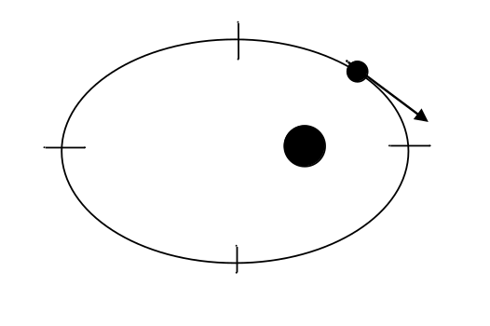
C
A
B

______ 1. A planet orbits a star in an elliptical orbit as pictured above. The arrow shows the direction of the planet’s motion. It takes longest for the planet to move from:
(a) A to C
(b) B to D
(c) C to A
(d) All of these times are the same.

______ 2. High tides on the Earth are higher:
(a) during the full moon (once per month).
(b) during the new moon (once per month).
(c) during both the full and new moons (twice per month).
(d) in the spring (one long season per year).

______ 3. The angular momentum of a planet is
- is higher at perihelion than at aphelion.
- is higher at aphelion than perihelion.
- is the same at perihelion and aphelion.
- depends on the direction from which it is observed.

______ 4. If the apparent magnitude a star is 6 in the V filter and 7 in the B filter, how far away is the star?
- 1.6 pc
- 6.3 pc
- 25 pc
- It is impossible to tell from the information given.

______ 5. The Arecibo radio telescope is 305 meters in diameter, and detects frequencies from 50 megahertz (6 m wavelength) up to 10,000 megahertz (3 cm wavelength). Approximately what is the diffraction limited resolution, when surveying the 21 cm radiation from the sky?
- 0.0005°
- 0.05°
- 0.5°
- 5°

______ 6. If a star has an absolute M_{V} magnitude of 1.0 and a distance of 10 kpc, what apparent V magnitude will we observe?
(a) 1
(b) 7.5
(c) 16
(d) 35.5

______ 7. If the temperature of a blackbody is increased, then:
- the peak wavelength and flux of the emitted light both increase.
- the peak wavelength and flux of the emitted light both decrease.
- the peak wavelength of the emitted light decreases while the flux increases.
- the peak wavelength of the emitted light increases while the flux decreases.

______ 8. What is the wavelength of the lowest energy Balmer series photon that can be emitted by a hydrogen atom?
- 91.18 nm
- 121.57 nm
- 364.71 nm
- 656.47 nm

Definitions (2 points each, 10 points total)

1. synodic period –

2. ecliptic plane –

3. meteor –

4. spectrograph –

5. Roche limit –

Problems requiring calculation (42 points total)

You must show your work (and units) to receive credit. Partial credit will be assigned.

1. (4 points) If the oblateness of a planet is zero, what is the eccentricity of its cross section, in a plane that includes both the north and south poles?

2. (4 points) The diagram below shows two masses separated by a distance d. The masses are related by M₁ = 3M₂.
(a) Determine the position of the center of mass of the system and indicate its position on the diagram.

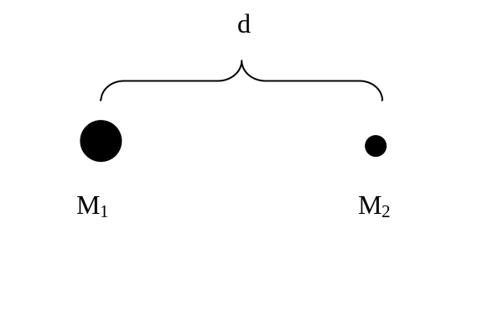

(b) (3 points) If the sidereal period of mass 1 is one year, what is the sidereal period of mass 2?

3. Astronomers notice that the maximum elongation of Venus is 48°,
(a) (4 points)What is the distance from the Sun to Venus?

(b) (4 points)What is the sidereal period of Venus?

4. (a) (6 points) What is the flux of light from the Sun at a distance of 1 AU away?

(b) (4 points) How much energy from the Sun hits the Earth in one second?

(c) (2 points) If the albedo of the Earth is 0.367, how much energy in sunlight is absorbed by the Earth in second?

(d) (3 points) At what temperature is the rate of energy lost to blackbody radiation from the Earth equal to the rate of energy absorption from the Sun?

(e) (2 points) What is the peak wavelength of blackbody radiation at this temperature?

(f) (3 points) How do you reconcile this peak wavelength with the fact that the Earth looks blue?

Essay (25 points total)

I am looking for a clear and readable explanation in response to this question. Please use complete sentences. Diagrams or equations can be included if they clarify what you are writing (and count for credit). Complex sentences may be judged to contain more than one information unit, and may count for additional credit. I cannot read your mind, so you will have to write what you are thinking on the paper.
Two points will be added for correct and relevant pieces of information (sentences, drawings, equations with explanation), and three points will be subtracted for sentences which show misunderstanding of physics or astronomy. Five points are reserved for overall clarity and style of answer. No credit will be assigned for sentences that are illegible, contain repeated information, or are uninformative.
A minimum of ten informative sentences (and/or diagrams and/or equations) is required for full credit on this essay.

How can one determine the mass of Jupiter by measuring the positions of its moons?

Astronomical Constants

Astronomical Unit AU = 1.496 x 10¹¹ m

Parsec pc = 206,265 AU
= 3.26 ly
= 3.086 x 10¹⁶ m

Light year ly = 6.324 x 10⁴ AU
= 0.307 pc
= 9.46 x 10¹⁵ m

Sidereal year 1 year = 365.26 days
=3.16 x 10⁷ s

Mass of Earth M⊕ = 5.98 x 10²⁴ kg

Radius of Earth R⊕ = 6378 km
at equator

Orbital velocity V⊕ = 30 km/s
of Earth

Mass of Sun M = 1.99 x 10³⁰ kg

Radius of Sun R = 6.96 x 10⁵ km

Luminosity of Sun L = 3.90 x 10²⁶ W

Effective temp T_{eff} = 5780 K
of Sun

Mass of Moon M_{Moon} = 7.3 x 10²² kg
= 0.0123 M⊕

Radius of Moon R_{Moon} = 1738 km
= 0.273 R⊕

Radius of Moon’s d_{Moon} = 3.84 x 10⁵ km
orbit

Sidereal month P_{Moon} = 27.3 days
Synodic month = 29.5 days

Distance of Sun R₀ = 8.5 kpc
from Galaxy center

Velocity of Sun V₀ = 220 km/s
aboutGalactic center

Diameter of Galaxy = 50 kpc

Mass of Galaxy M = 7 x 10¹¹ M

Physical and Mathematical Constants

Velocity of light c = 3.00 x 10⁸ m/s

Gravitational const. G = 6.67 x 10⁻¹¹ N m²/kg²

Planck constant h = 6.623 x 10⁻³⁴ J s

Boltzmann constant k = 1.38 x 10⁻²³ J/K

Rydberg constant R = 1.097 x 10⁷ m⁻¹

Stefan-Boltzmann σ = 5.67 x 10⁻⁸ W/(m² K⁴)
Constant

Wien’s Law const. λ_{max}T = 2.898 x 10⁷ Å K

Mass of hydrogen m_{H} = 1.67 x 10⁻²⁷ kg
atom = 1.0078 amu

Mass of helium atom m_{He} = 4.0026 amu

Mass of electron m_{e} = 9.11 x 10⁻³¹ kg

Charge of electron e = 1.60 x 10⁻¹⁹ C

Electron volt 1 eV = 1.602 x 10⁻¹⁹ J

π = 3.1416

e = 2.7183; log₁₀e = 0.4343

Atomic mass unit amu = 1.660539 x 10⁻²⁷ kg

Proton mass m_{p} = 1.007277 amu

Neutron mass m_{n} = 1.008655 amu

Kepler’s Laws

(1) The orbit of each planet is an ellipse with the Sun at one focus.
(2) The radius vector to a planet sweeps out equal areas in equal intervals of time.
(3) The squares of the sidereal periods of the planets are proportional to the cubes of the semimajor axes of their orbits.

a ae
a
a
b

Newtonian Physics

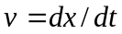
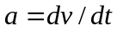
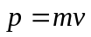
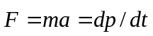
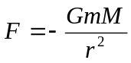
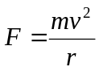 (for circles)
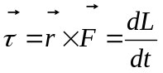
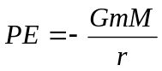
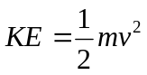
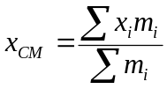
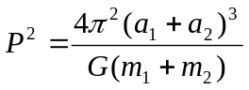
Electromagnetic Radiation

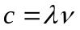
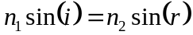
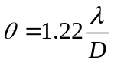
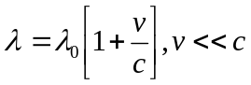
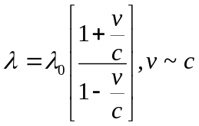
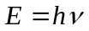
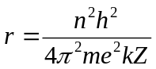
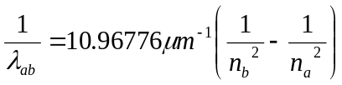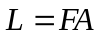

Blackbody Radiation
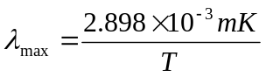
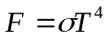
Properties of Planets

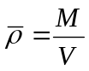
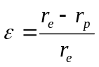

Atmospheres

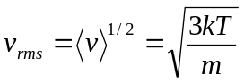
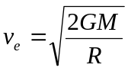

Tidal Forces

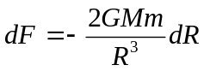
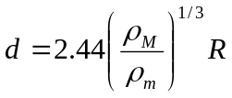

Stellar Structure

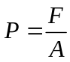
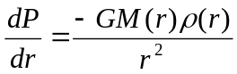
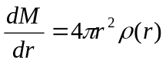
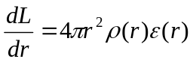
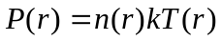
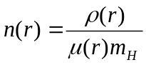
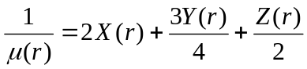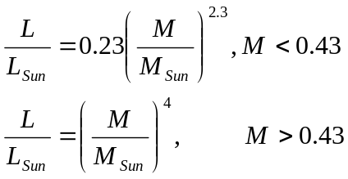
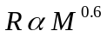

Viral Theorem

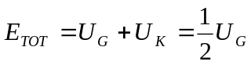
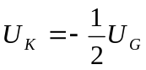

Magnitudes & Distances

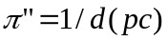
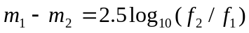
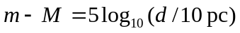
Color Index = m(λ₁) – m(λ₂)

Variable Stars

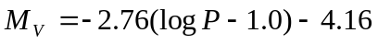 (period in days)

Stellar Counts
log N(m) = 0.6m + C
(const. density, single abs. mag.)

Redshift
z ≡ (λ-λ₀)/λ₀
≈ v/c for small z

Hubble’s Law
v = H₀d

Large z, flat Universe
d = cz(1+z/2)/[H₀(1+z)²]

Nova peak magnitude
M_{V}^{max} = -9.96 – 2.31 log(m)

Black Holes
R = 2GM/c²
= 3M km (M in M)

Cosmology
